Assignment No. 03
- TITLE – Implement basic array operations such as insert, delete, and merge, while simulating a 2D array using a single-dimensional array to optimize space (using both row-major and column-major formats). Use pointer arithmetic to print memory addresses of elements, helping you understand how arrays are stored in memory.

- THEORY –
1. Arrays in C++
An array is a collection of elements of the same data type stored in contiguous memory locations. It allows random access to elements using indices.
Basic Array Operations:
- Insertion – Add a new element at a given index.
- Deletion – Remove an element (shift or set to 0).
- Traversal – Access and display all elements sequentially.
- Searching – Find an element’s position in the array.
- Merging – Combine two arrays into one larger array.
Arrays provide O(1) access time but O(n) insertion/deletion in general (since elements may need shifting).

2. 2D Arrays
A 2D array is essentially an array of arrays. It is used to represent tabular data (like matrices). In memory, however, a 2D array is stored linearly.
- For int arr[3][3], although it looks like a grid, elements are stored in contiguous memory as a 1D sequence.

3. Representing a 2D Array Using a 1D Array
Instead of directly declaring arr[rows][cols], we can simulate it using a single-dimensional array with rows * cols elements.
We need a mapping function to calculate the index in the 1D array from a pair (i, j):
- Row-Major Order
  - Rows are stored one after another.
  - Formula:
index=i×cols+jindex = i \times cols + jindex=i×cols+j
Example: In a 3×3 array, element (1,2) (row=1, col=2) is stored at index 1*3 + 2 = 5.
- Column-Major Order
  - Columns are stored one after another.
  - Formula:
index=j×rows+iindex = j \times rows + iindex=j×rows+i
Example: In a 3×3 array, element (1,2) is stored at index 2*3 + 1 = 7.
This mapping allows us to simulate 2D arrays using a 1D array.

4. Row-Major vs Column-Major Layouts
- Row-Major
Elements of the same row are stored consecutively in memory.
- Row-Major (3x3):
- [a00 a01 a02 a10 a11 a12 a20 a21 a22]
- Column-Major
Elements of the same column are stored consecutively.
- Column-Major (3x3):
- [a00 a10 a20 a01 a11 a21 a02 a12 a22]
Understanding both layouts is important for performance optimization and memory addressing.

5. Pointer Arithmetic and Memory Addresses
In C++, arrays are closely tied to pointers.
- The name of the array is a pointer to the first element.
- The address of element (i, j) can be computed as:
For row-major:
Address(i,j)=Base Address+(i×cols+j)×Size of data type
For column-major:
Address(i,j)=Base Address+(j×rows+i)×Size of data type

- ALGORITHM –
1. Create Array2D class with members: dynamic array data, dimensions rows, cols, and size.
2. In constructor, allocate rows*cols memory and initialize elements to 0.
3. Define index mapping:
- Row-major → i*cols + j
- Column-major → j*rows + i
4. Implement operations:
- Insert (row/col major) → place value at computed index.
- Delete → set element to 0.
- Print → display elements with memory addresses using pointer arithmetic.
5. Input elements row-wise from user.
6. Implement merge() → create larger array, copy first array, then append second array.
7. In main():
- Take dimensions, create object, input elements.
- Print in row-major and column-major layouts.
- Delete an element and reprint.
- Merge with another array and display result.
8. Use destructor to free memory.

- EXAMPLE –
1. Example Of Implementation
Enter number of rows and columns respectively:
3 3
Enter elements for a 3x3 array (row-wise):
Element (0,0): 1
Element (0,1): 2
Element (0,2): 3
Element (1,0): 4
Element (1,1): 5
Element (1,2): 6
Element (2,0): 7
Element (2,1): 8
Element (2,2): 9
Row-Major Layout:
1(0x600003600) 2(0x600003604) 3(0x600003608)
4(0x60000360C) 5(0x600003610) 6(0x600003614)
7(0x600003618) 8(0x60000361C) 9(0x600003620)

Column-Major Layout:
1(0x600003600) 4(0x60000360C) 7(0x600003618)
2(0x600003604) 5(0x600003610) 8(0x60000361C)
3(0x600003608) 6(0x600003614) 9(0x600003620)

Deleting element in row-major...
Row-Major Layout:
1(0x600003600) 2(0x600003604) 3(0x600003608)
0(0x60000360C) 5(0x600003610) 6(0x600003614)
7(0x600003618) 8(0x60000361C) 9(0x600003620)

Merging two arrays:
1(0x600005600) 2(0x600005604) 3(0x600005608)
0(0x60000560C) 5(0x600005610) 6(0x600005614)
7(0x600005618) 8(0x60000561C) 9(0x600005620)
100(0x600005624) 0(0x600005628) 0(0x60000562C)
0(0x600005630) 200(0x600005634) 0(0x600005638)

- CODE –
#include <iostream>
using namespace std;

class Array2D {
int *data;
int rows, cols, size;
public:
Array2D(int r, int c){
rows=r;
cols=c;
size=rows*cols;
data=new int[size];
for (int i=0; i<size; i++){
data[i]=0;
}
}

int rowMajorIndex(int i, int j){
return i*cols+j;
}

int colMajorIndex(int i, int j){
return j*rows+i;
}

void insertRowMajor(int i, int j, int val){
int index=rowMajorIndex(i, j);
data[index]=val;
}

void insertColMajor(int i, int j, int val){
int index=colMajorIndex(i, j);
data[index]=val;
}

void deleteRowMajor(int i, int j){
int index=rowMajorIndex(i, j);
data[index]=0;
}

void printRowMajor(){
cout <<endl<<"Row-Major Layout:"<<endl;
for (int i=0; i<rows; i++) {
for (int j=0; j<cols; j++) {
int idx=rowMajorIndex(i, j);
cout<<data[idx]<<"("<<(data + idx)<<")\t";
}
cout<<endl;
}
}

void printColMajor(){
cout<<"\nColumn-Major Layout:"<<endl;
for (int i=0; i<rows; i++) {
for (int j=0; j<cols; j++) {
int idx = colMajorIndex(i, j);
cout<<data[idx]<<"("<<(data + idx)<<")\t";
}
cout<<endl;
}
}

void inputElementsRowMajor(){
cout << "Enter elements for a " << rows << "x" << cols << " array (row-wise):" << endl;
for (int i = 0; i < rows; i++) {
for (int j = 0; j < cols; j++) {
int val;
cout << "Element (" << i << "," << j << "): ";
cin >> val;
insertRowMajor(i, j, val);
}
}
}

static Array2D merge(Array2D &a, Array2D &b){
int newRows=a.rows +b.rows;
int newCols=max(a.cols, b.cols);
Array2D result(newRows, newCols);

for (int i = 0; i < a.rows; i++) {
for (int j = 0; j < a.cols; j++) {
result.insertRowMajor(i, j, a.data[a.rowMajorIndex(i, j)]);
}
}
for (int i = 0; i < b.rows; i++) {
for (int j = 0; j < b.cols; j++) {
result.insertRowMajor(i + a.rows, j, b.data[b.rowMajorIndex(i, j)]);
}
}
return result;
}
~Array2D(){
delete[] data;
}
};

int main() {
cout<<"Enter number of rows and columns respectively: "<<endl;
int r, c;
cin>>r>>c;
Array2D arr(3, 3);
arr.inputElementsRowMajor();

arr.printRowMajor();
arr.printColMajor();

cout << "\nDeleting element in row-major..." << endl;
arr.deleteRowMajor(1, 0);

arr.printRowMajor();

cout << "\nMerging two arrays:" << endl;
Array2D arr2(2, 3);
arr2.insertRowMajor(0, 0, 100);
arr2.insertRowMajor(1, 1, 200);

Array2D merged = Array2D::merge(arr, arr2);
merged.printRowMajor();

return 0;
}

- OUTPUT –

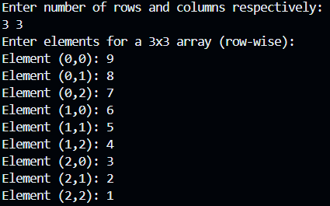
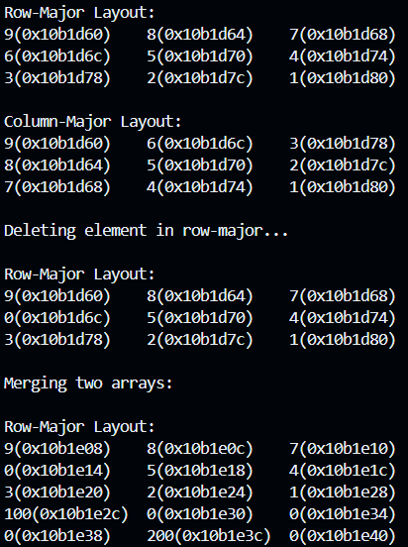

- CONCLUSION –
In this practical, we have observed that Arrays can be efficiently simulated using a single-dimensional array with row-major and column-major mappings. This implementation demonstrates basic operations, memory layout, and pointer arithmetic for better understanding of array storage.

